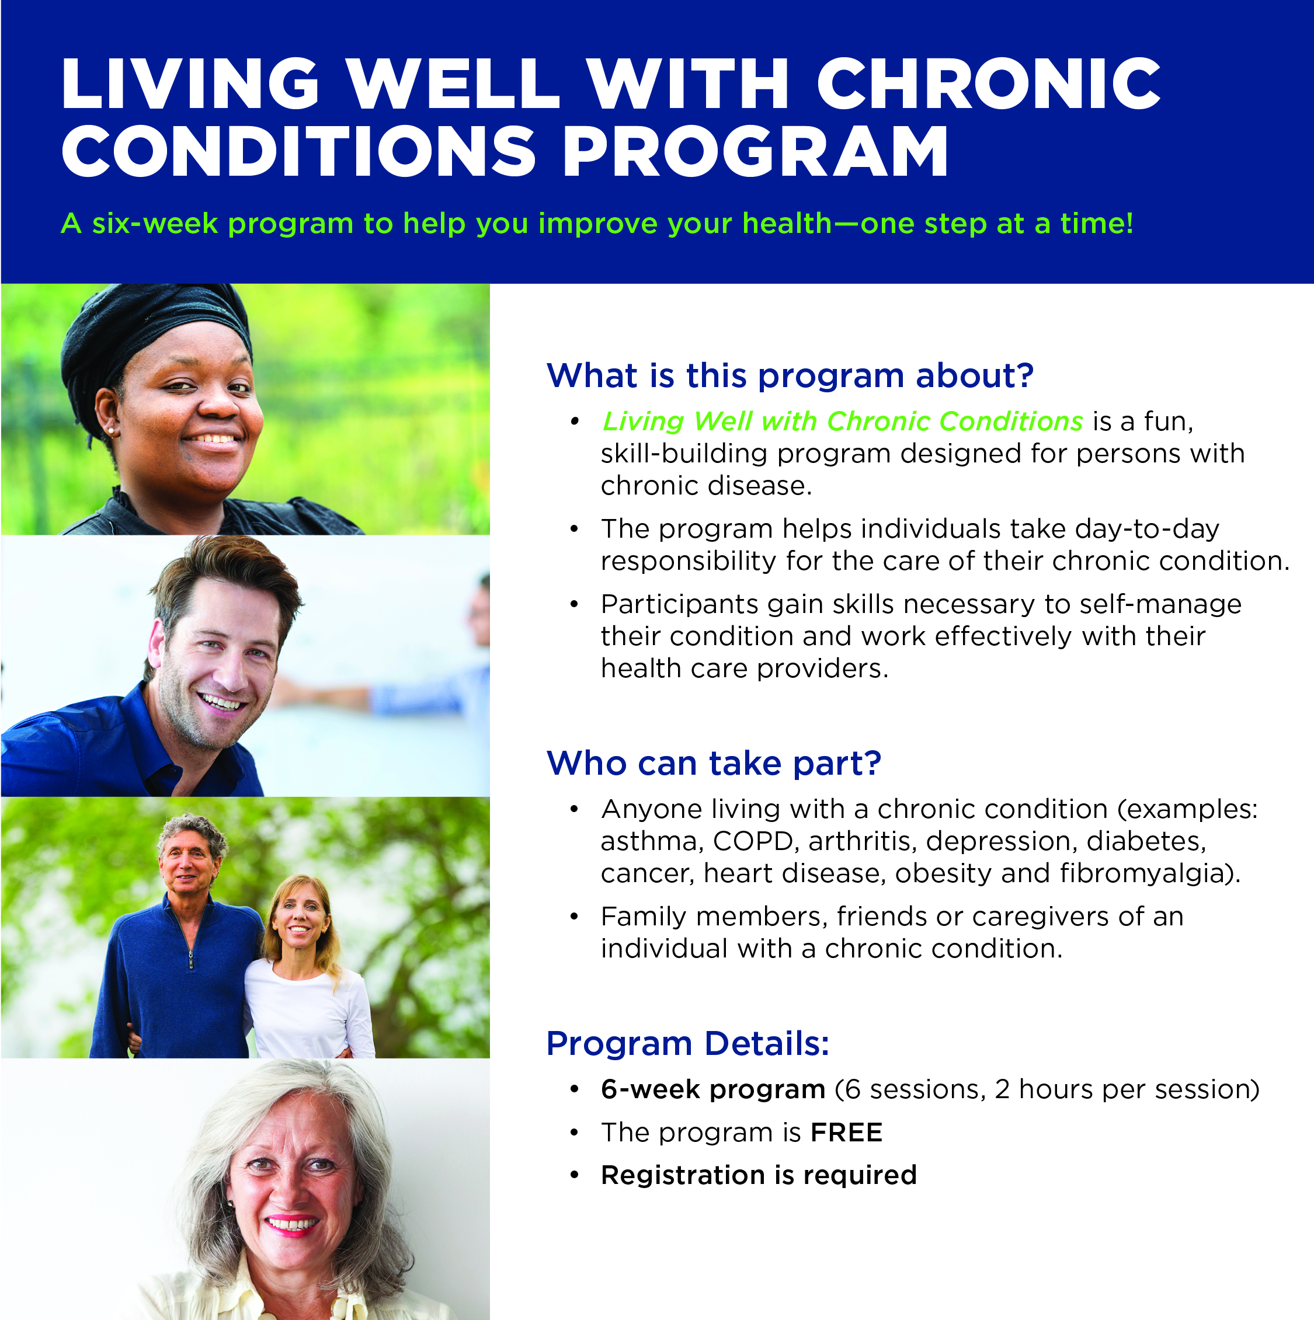

For more information or to register, contact:

Dates:
Times:
Location:
Deadline to Register:

